Examples of Interfaces used in the study

This document provides examples of the interfaces used in the different stages of the study for each of the two conditions evaluated (Node-link and Adjacency Matrice).

Stages: Participants were first shown an introduction to a condition of the study, followed by a color-blindness test and performing training tasks. Participants then performed the actual study and provided some feedback.

1. Color-blindness test (Figure 1).

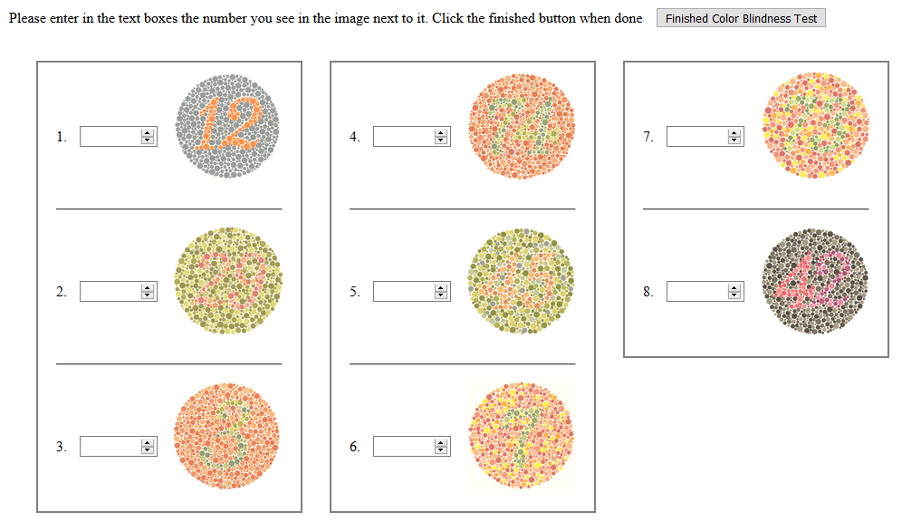
Figure 1: Color blindness test administered to study participants.

2. Introduction to the Node-link condition (Figure 2).

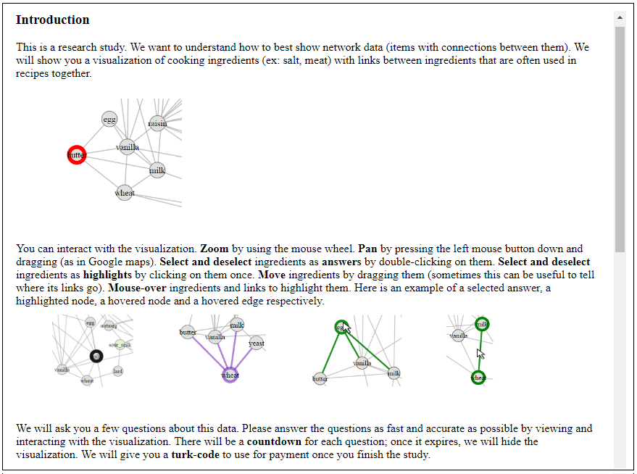

Figure 2: An example of an Introduction to the Node-link condition of the study.

3. Tasks and answers samples provided to participants in the Node-link condition (Figure 3).
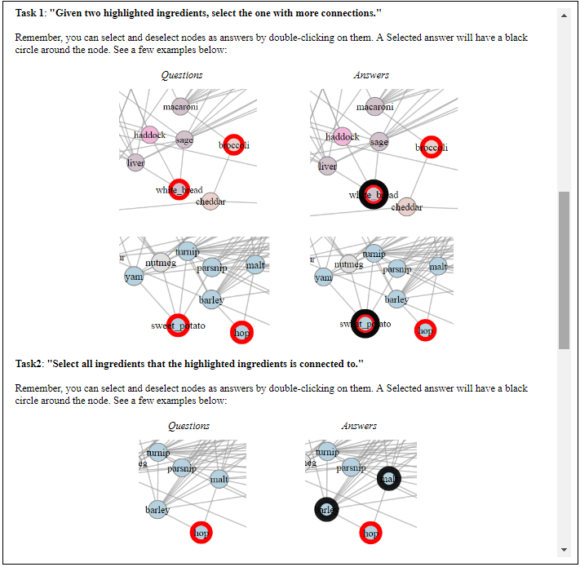
Figure 3: An example of task samples provided as part of the introduction to the node-link condition.

4. Training Tasks in the Node-link condition (Figure 4).

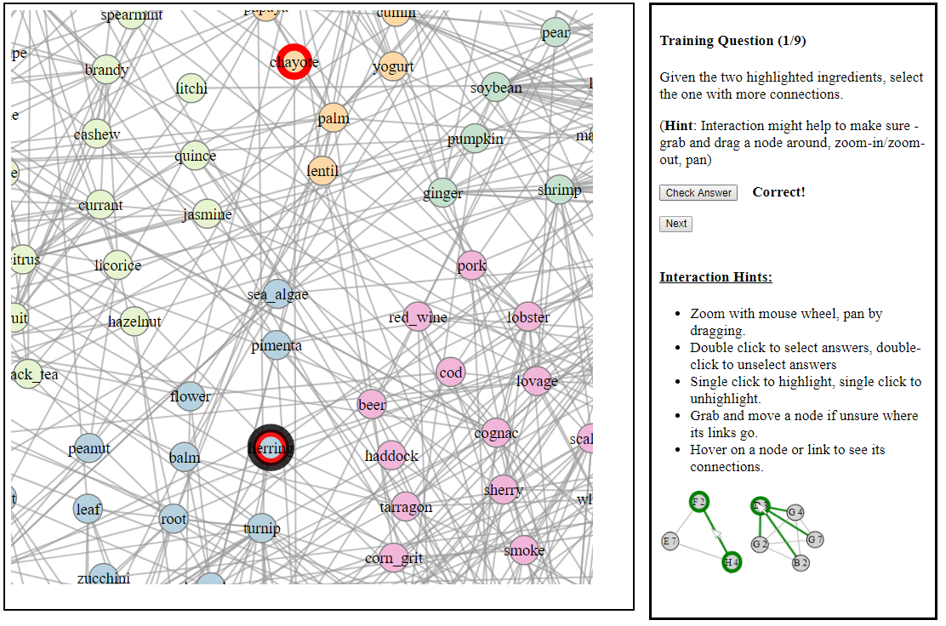
Figure 4: An example of training tasks performed by participants in the Node-link condition. Training tasks were not timed, and participants could check the accuracy of their responses.

5. Study tasks in the node-link condition (Zoomed out) (Figure 5).
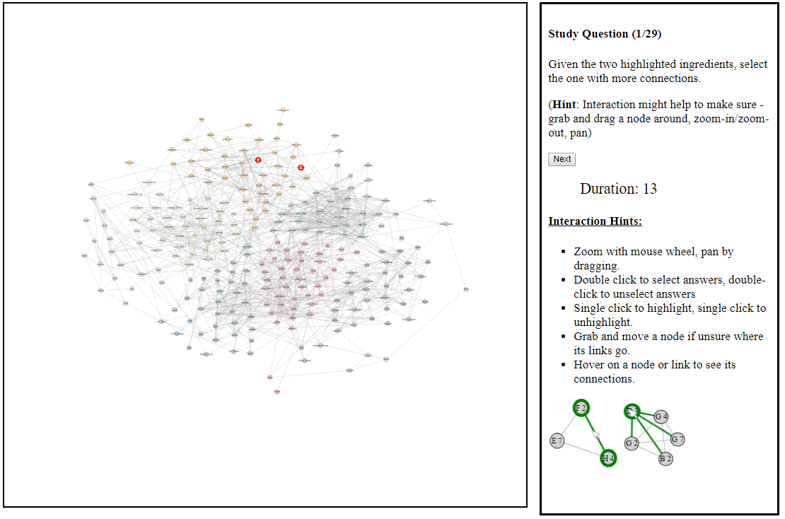
Figure 5: An example of an actual study in the Node-link condition. Each task instance starts zoomed out. There is a countdown timer, and the visualization gets hidden when the timer gets to zero.

6. Study task in the node-link condition (Zoomed-in) (Figure 6)
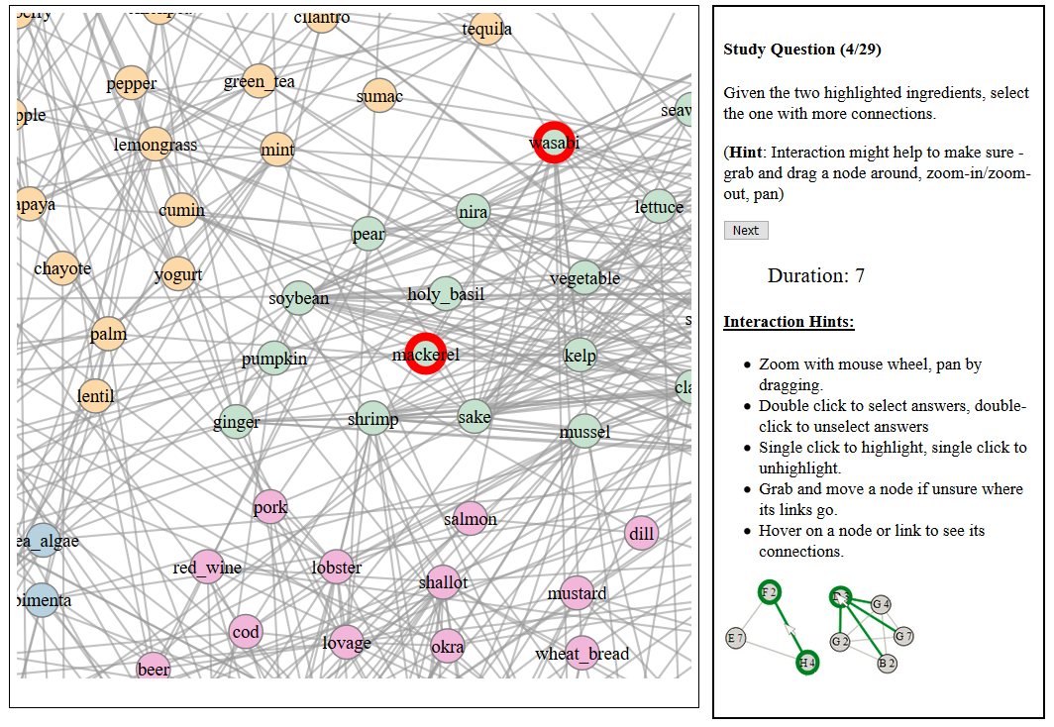
Figure 6: An example of a study in the node-link condition with the visualization zoomed in.

7. Feedback page shown to participants in the node-link condition (Figure 7).
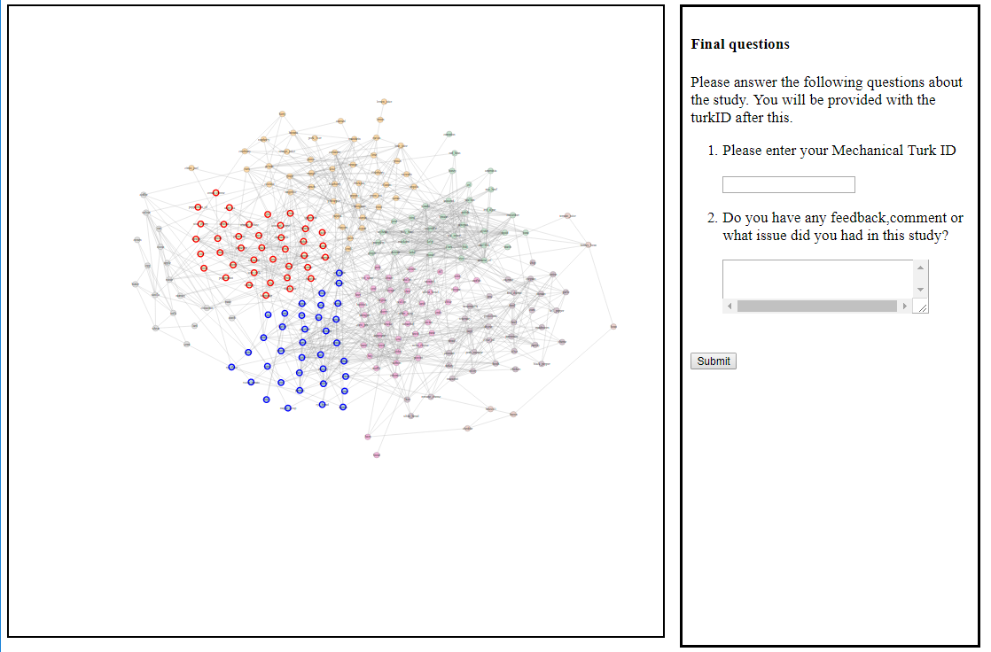
Figure 7: An example of the feedback page shown to users after the study in the node-link condition.

8. Introduction to the Adjacency Matrice condition (Figure 8).

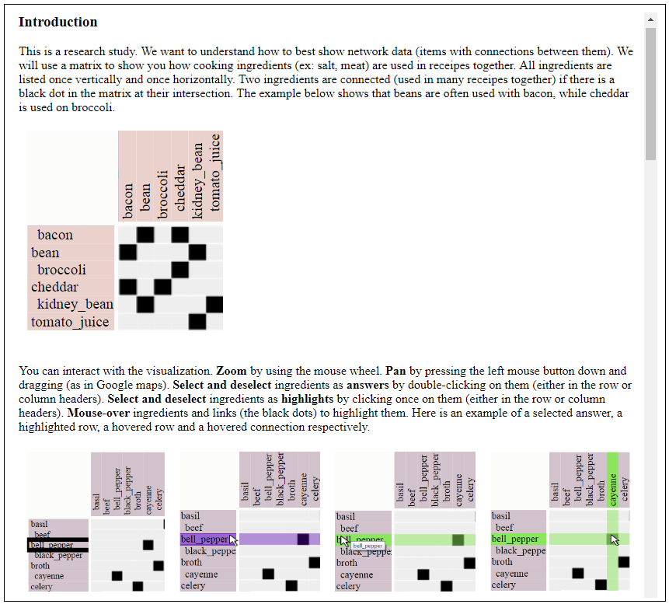
Figure 8: An example of an Introduction to the adjacency matrice condition of the study.

9. Task and answer samples provided in the introduction of the Adjacency Matrice condition (Figure 9)
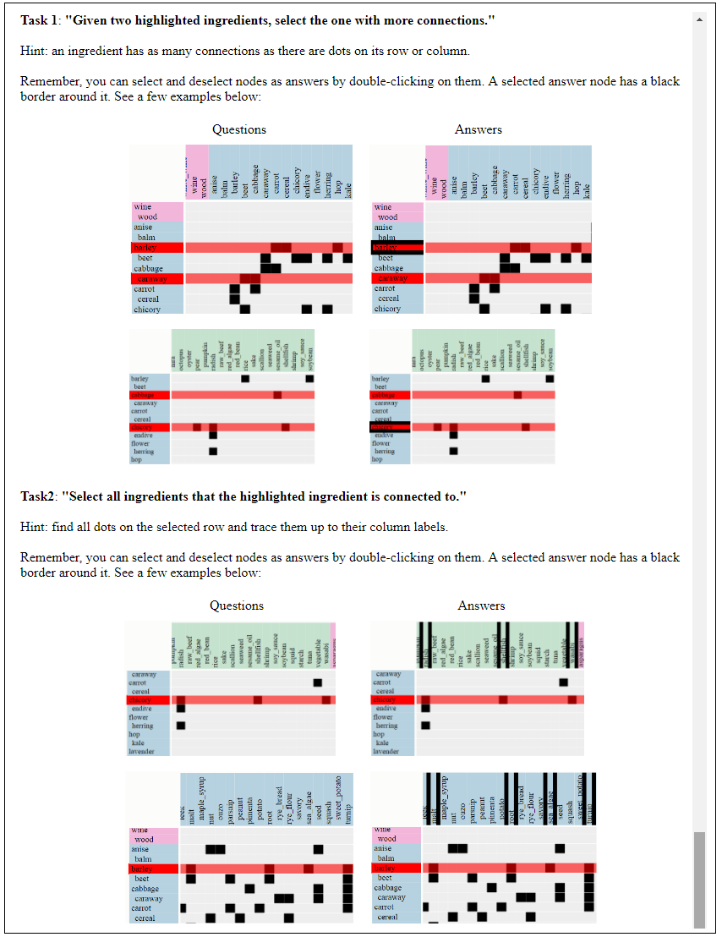
Figure 9: An example of task samples provided in the introduction of the adjacency matrice condition.

10. Study Task in the Adjacency Matrice condition (Zoomed out) (Figure 10).

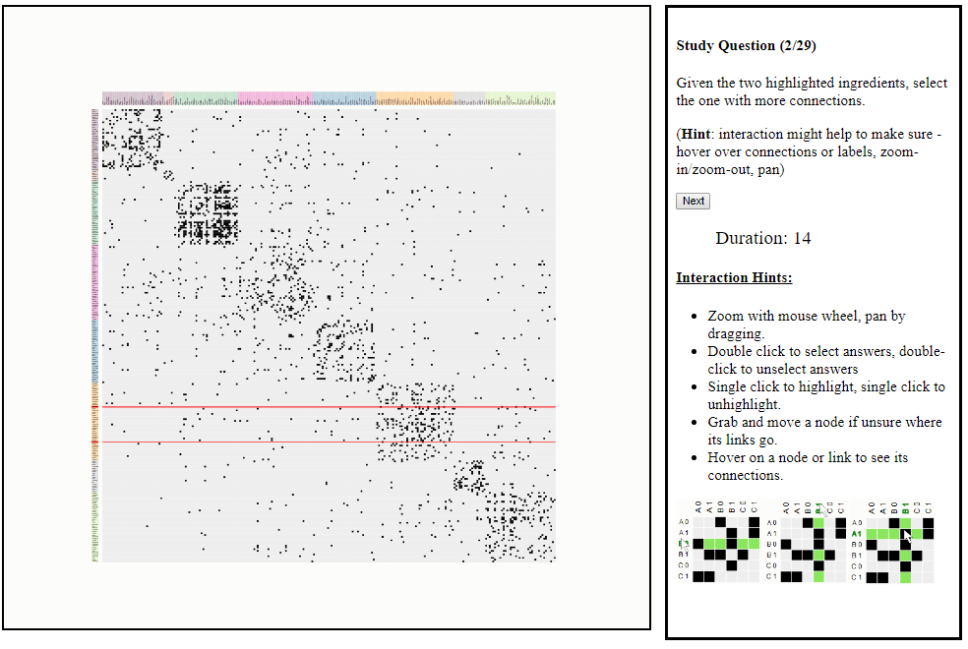
Figure 10: An example of an actual study in the adjacency matrice condition. Each task instance starts with the visualization zoomed out. A countdown timer is started and the visualization is hidden when the countdown gets to zero.

11. Study Task in the Adjacency Matrice condition (Zoomed-in) (Figure 11).

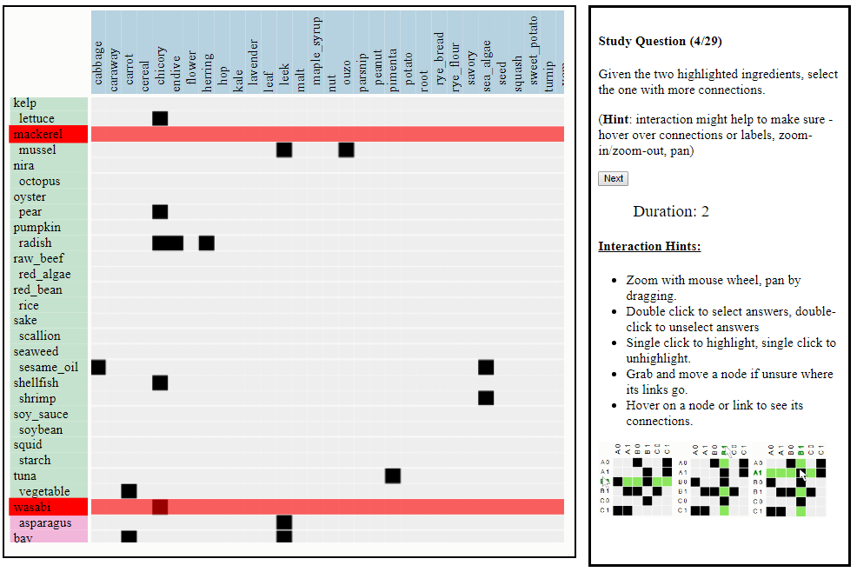
Figure 11: An example of study with the adjacency matrice visualization zoomed in.

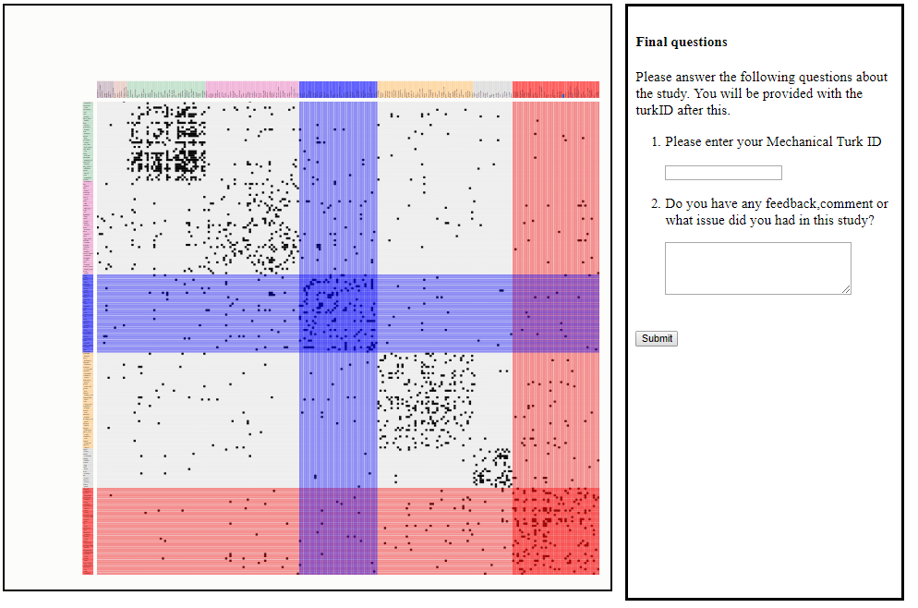

12. Feedback page shown to participants in the Adjacency Matrice condition (Figure 12).

Figure 12: Participants provided feedback at the end of the study.

